Chapter 17, Solution 75.

The lowpass filter is shown below.

R

+ +
v_{s} C v_{o}

- -

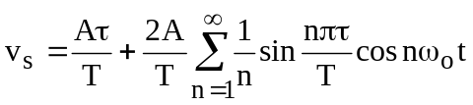

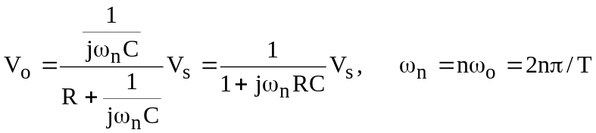

For n=0, (dc component), 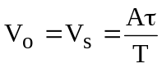 (1)
For the nth harmonic,

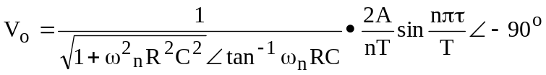

When n=1, 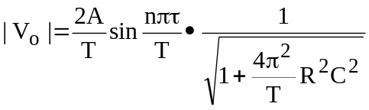 (2)

From (1) and (2),

